1.Write html code to develop a web page having two frames that divide the webpage into two
equal
rows and then divide the row into equal columns and fill each frame with a different background
color.

<html>
<head>
<title>Combined Frames</title>
</head>

<frameset rows="50%,50%">

<!-- Top Row -->
<frameset cols="50%,50%">
<frame src="data:text/html,<body bgcolor='red'></body>">
<frame src="data:text/html,<body bgcolor='blue'></body>">
</frameset>

<!-- Bottom Row -->
<frameset cols="50%,50%">
<frame src="data:text/html,<body bgcolor='green'></body>">
<frame src="data:text/html,<body bgcolor='yellow'></body>">
</frameset>

</frameset>

</html>

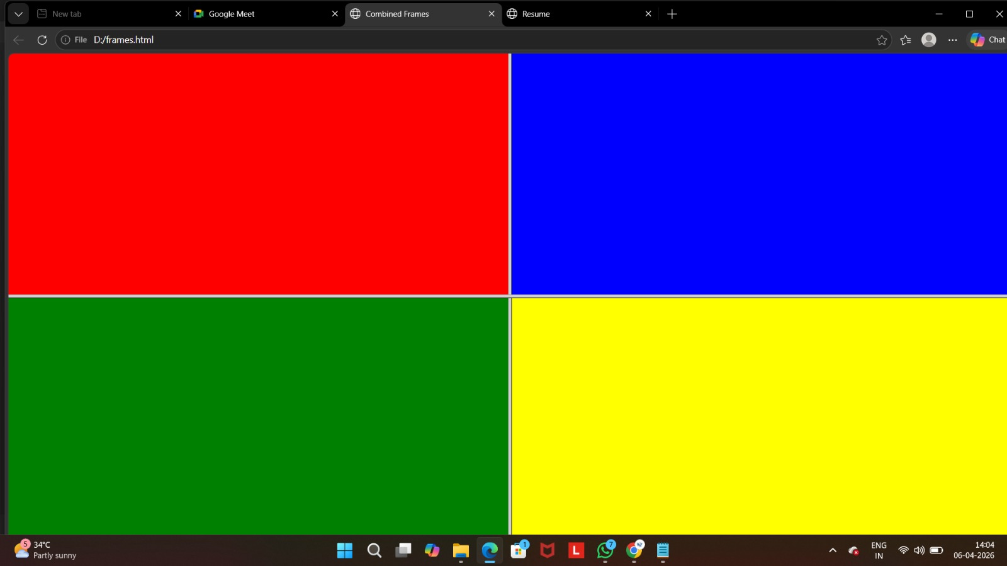

2. Design web pages for your college containing a description of the courses, departments,
faculties,library etc, use href, list tags.
<html>
<head>
<title>My College</title>
</head>

<body>

<h1>ABC College</h1>

<h2>Departments</h2>
<ul>
<li>Computer Science</li>
<li>Electronics</li>
<li>Commerce</li>
</ul>

<h2>Courses</h2>
<ol>
<li>BSc Computer Science</li>
<li>BCom</li>
<li>BA English</li>
</ol>

<h2>Facilities</h2>
<ul>
<li>Library</li>
<li>Laboratory</li>
<li>Sports</li>
</ul>

<p>Visit our website:
<a href="https://www.google.com">Click here</a>
</p>

</body>
</html>

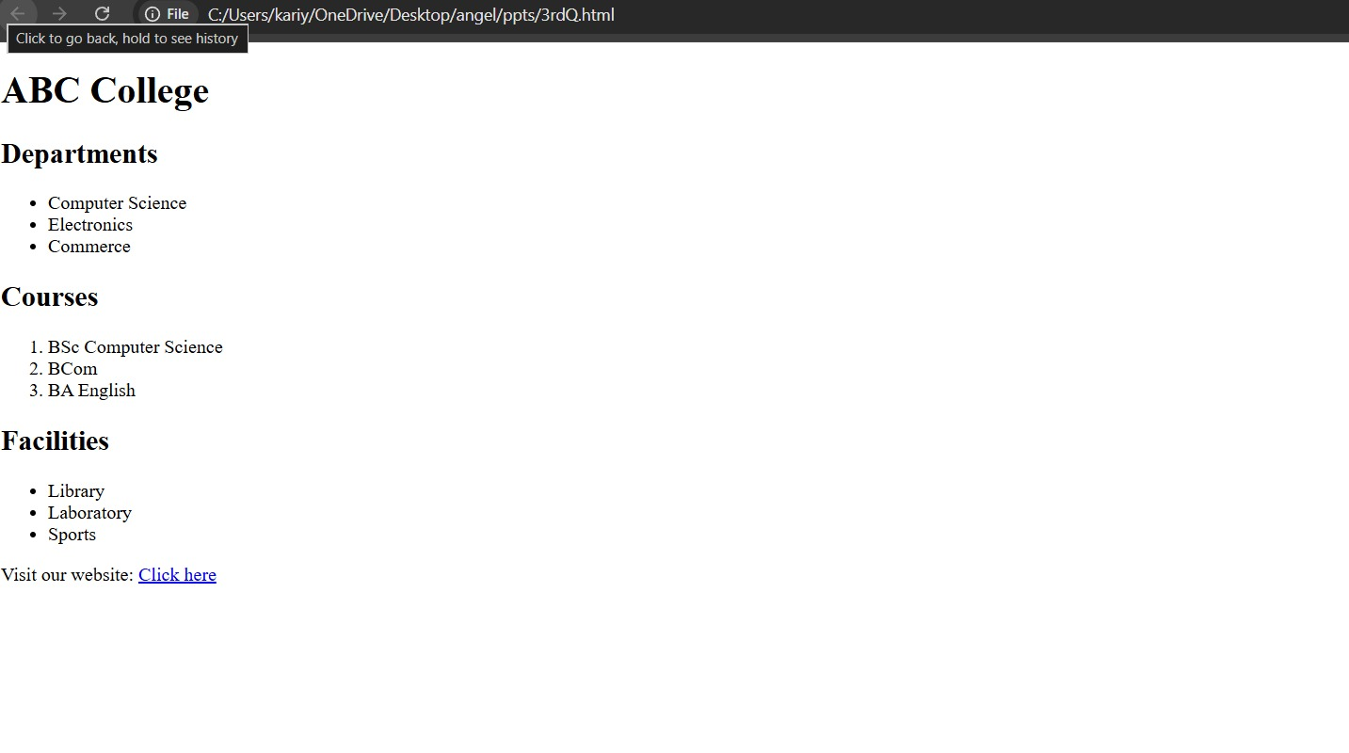

3.Create your resume using HTML tags and also experiment with colors, text , link , size and
also other tags you studied.
<html>
<head>
<title>Resume</title>
</head>

<body bgcolor="lightblue">

<h1 align="center">Your Name</h1>

<p><b>Email:</b> your@email.com</p>
<p><b>Phone:</b> 1234567890</p>

<h2>Objective</h2>
<p>To become a successful professional.</p>

<h2>Education</h2>
<ul>
<li>Plus Two</li>
<li>High School</li>
</ul>

<h2>Skills</h2>
<ul>
<li>HTML</li>
<li>JavaScript</li>
</ul>

<h2>Hobbies</h2>
<ul>
<li>Reading</li>
<li>Gaming</li>
</ul>

</body>
</html>
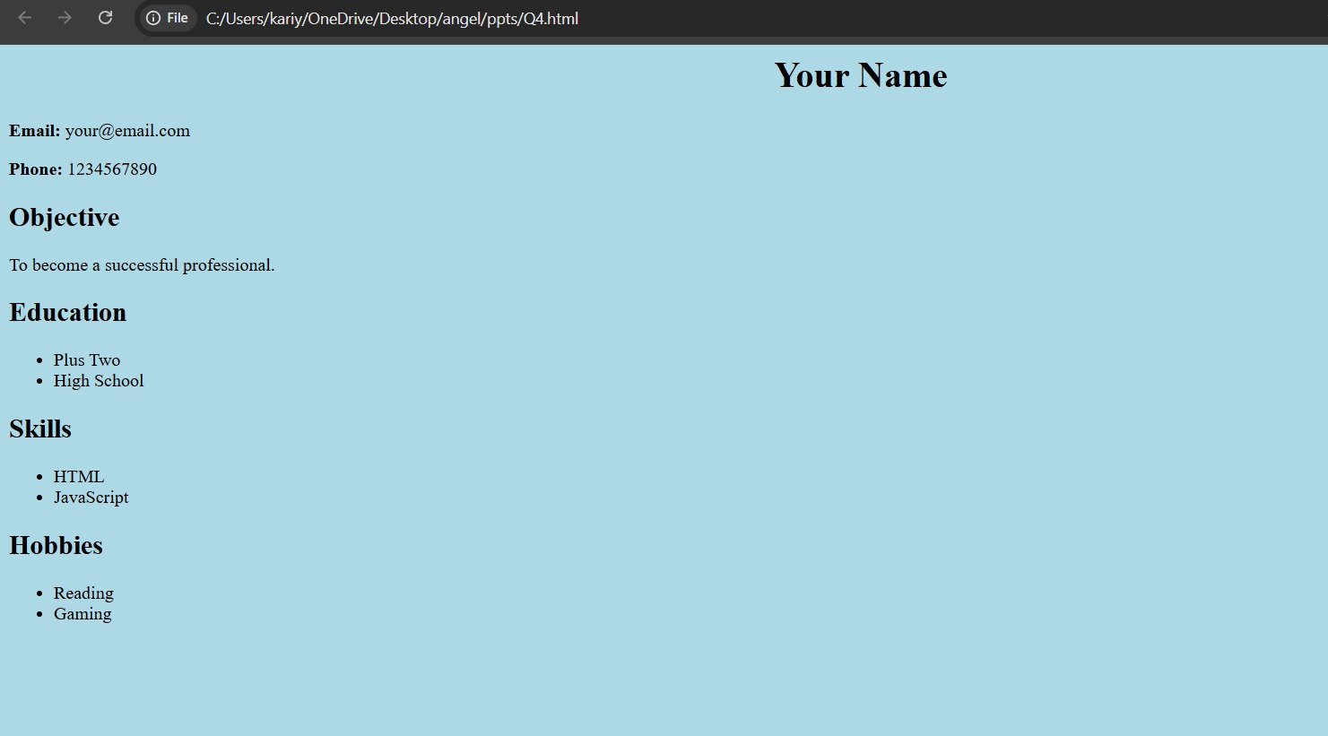

4.Design a web page of your home town with an attractive background color, text color, an
Image,font, etc. (use internal CSS).
<html>
<head>
<title>My Home Town</title>

<style>
body {
background-color: lightyellow;
color: darkblue;
font-family: Arial;
}
h1 {
color: green;
}
</style>

</head>

<body>

<h1>Kochi</h1>

<p>Kochi is a beautiful city in Kerala known for its backwaters and culture.</p>

<img src="https://trisoj.com/travel-guide/wp-content/uploads/2022/09/Tourist-Places-To-Visit-in-Kochi.jpg" width="300">

</body>
</html>
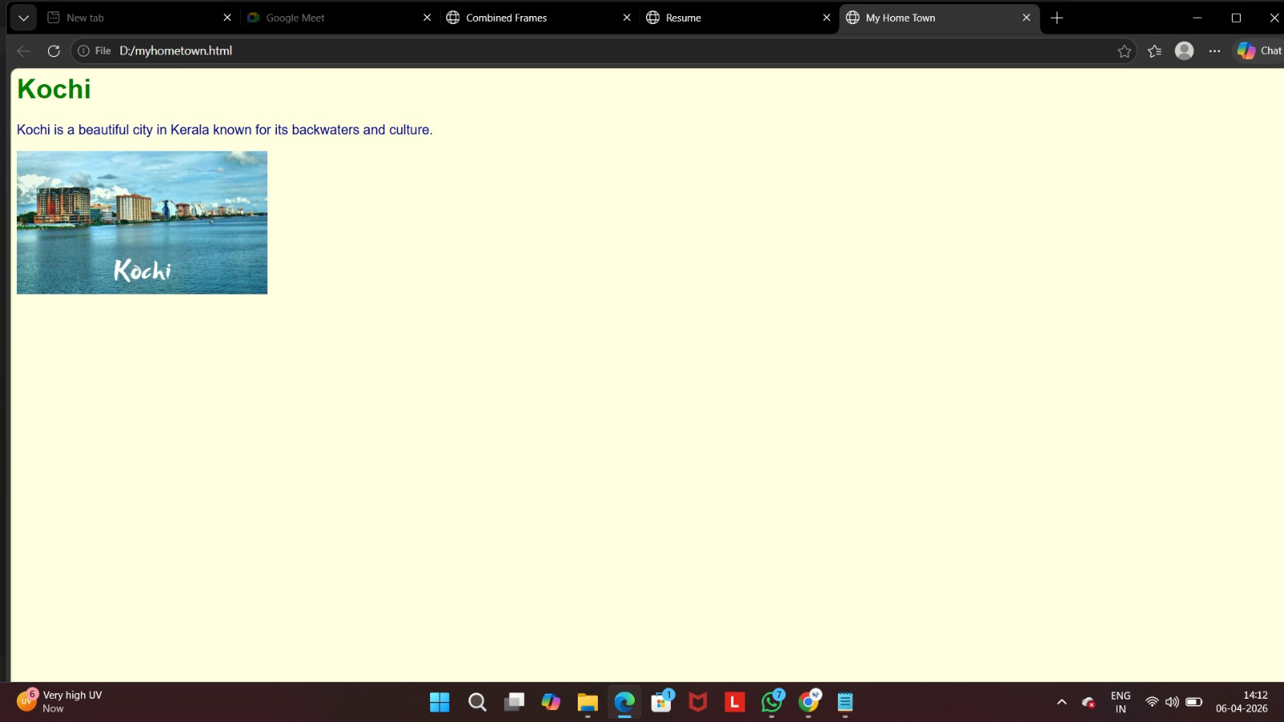

5. Design a blog layout using HTML and CSS

<html>
<head>
<title>Blog</title>

<style>
body {
font-family: Arial;
}
header {
background-color: black;
color: white;
padding: 10px;
}
article {
margin: 20px;
padding: 10px;
border: 1px solid gray;
}
</style>

</head>

<body>

<header>
<h1>My Blog</h1>
</header>

<article>
<h2>First Post</h2>
<p>This is my first blog post.</p>
</article>

<article>
<h2>Second Post</h2>
<p>This is another blog post.</p>
</article>

</body>
</html>
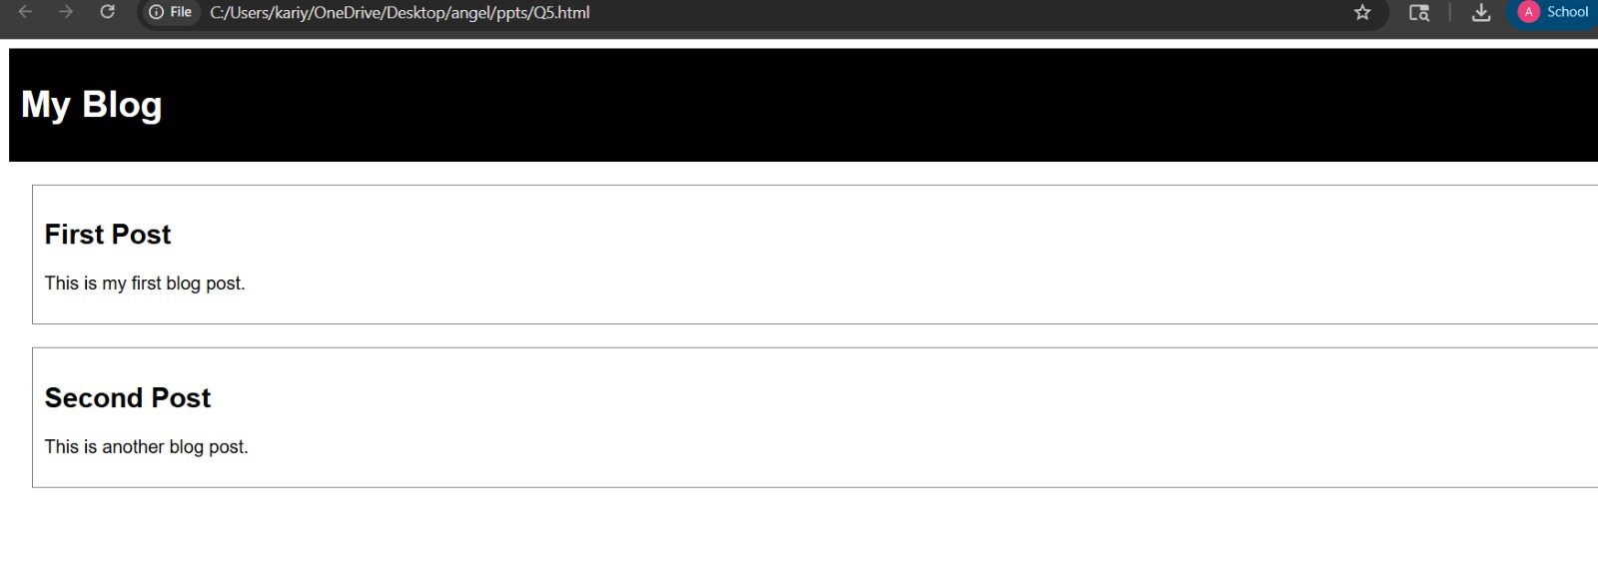
6.Write a JavaScript program to calculate and display the area of a rectangle. Prompt the user
to enter the length and width of the rectangle, and then compute the area using the formula:
area =length * width.

<html>
<head>
<title>Rectangle Area</title>
</head>

<body>

<script>
let length = prompt("Enter length:");
let width = prompt("Enter width:");

let area = length * width;

document.write("Area of rectangle = " + area);
</script>

</body>
</html>
